***Challenge 16***

**rs** command force nodemon to restart your server

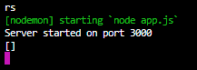

**Solution:**

App.js:

app.get('/posts/:postName', function(req, res){

console.log(req.params.postName);

});

**Verify by searcing:**

<http://localhost:3000/posts/apple> //apple is post name and can be changed